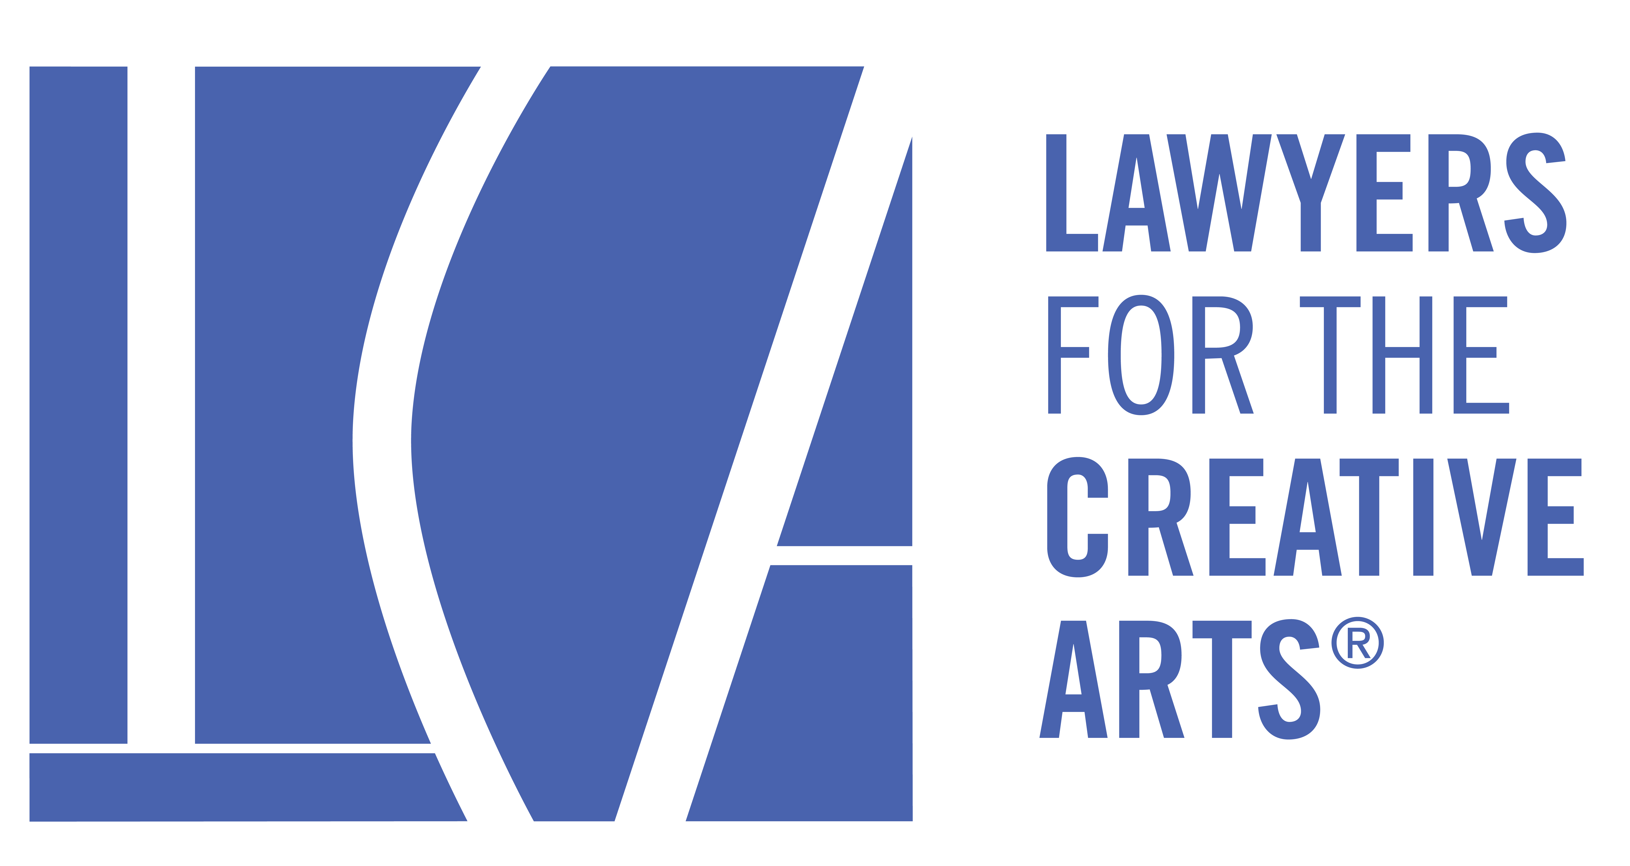

161 North Clark Street, Suite 4300, Chicago, Illinois 60601

The Associate Board of Lawyers for the Creative Arts
Prospective Member Profile

Please provide the following information so we can get to know a little more about you!

Name:_______________________________________________________________________

Pronouns: ___________________________________________________________________

Address:____________________________ City, State: __________________ Zip: _________

*Preferred Phone: ___________________________ Are you an Attorney? _______________

Business Name: ______________________________ Title: ___________________________

Address: ___________________________City, State: _________________ Zip: ___________

Phone: _____________________________ Fax: ____________________________________

*Preferred email: _____________________________________________________________

Secondary email:______________________________________________________________

Who/What introduced you to the Associate Board of Lawyers for the Creative Arts?
____________________________________________________________________________
____________________________________________________________________________

What LCA events have you attended or have you volunteered for LCA?
____________________________________________________________________________
____________________________________________________________________________

Each Associate Board Member is required to serve on ONE Committee. Please rank the top three committees you would like to serve on in order. Descriptions on Page 2. Options are as follows: a) Community Service/Outreach, b) Education, c) Events, d) Recruitment, e) Shindy f) Social Media
1) __________________________________________________________________________
2) __________________________________________________________________________
3) __________________________________________________________________________

Please also provide a picture of yourself so we can put a face to the name at our events!
Return this form and your photo via e-mail to associateboard@law-arts.org

*We will be in contact with you via email regarding your candidacy once the vote on your application is taken.
Thank you for your interest!!

161 North Clark Street, Suite 4300, Chicago, Illinois 60601

The Associate Board of Lawyers for the Creative Arts
committee DESCRIPTIONS

Community Service/Outreach
The Community Service/Outreach Committee is tasked with providing our membership the opportunity to assist other groups or organizations in need, preferably groups that have a similar mission or are otherwise related to the arts. The committee must plan at least (1) community service/outreach event each year.

Education
The Educational Committee is responsible for planning educational programs for artists focusing on legal concepts and/or continuing legal education programming for LCA volunteers and the legal community at large. The committee must plan at least (1) educational event for the larger community and at least (1) Associate Board Members-Only educational workshop each year.

Events
The Events Committee is tasked with creating and organizing social, networking and fundraising events for LCA. Throughout the year, the Events Committee will work to develop creative events that are of interest to LCA’s clients, volunteers, and Board Members, as well as to the public at large. The committee must plan at least (2) events each year.

Recruitment
The Recruitment Committee shall market, advertise and conduct public relations work on behalf of the Associate Board in an effort to grow the Associate Board Membership. The committee must plan at least (1) recruitment event each year.

Shindy
Each year, the Associate Board hosts the “Shindy,” a networking and fundraising opportunity for our artistic community. It is usually a festive evening filled with food, drink and live entertainment and presents an opportunity to not only raise money for LCA, but for members of the arts to meet and mingle with one another. This is the Associate Board’s biggest fundraiser of the year for LCA.

Social Media
The Social Media Committee is tasked with keeping apprised of legal news relevant to the LCA organization and its members, and assisting with various social media-centric projects focused on supporting the arts community, LCA as a whole, and the Associate Board specifically. The committee shall compile a list of news articles to create and generate posts to be shared across LCA's social media platforms on a regular basis. The committee will contribute and edit content, secure additional content contributors as needed, and promote LCA programs and events across all media platforms.

